**ANNEX P – ANIMAL EMERGENCIES**

**ESF #11 – AGRICULTURE & NATURAL RESOURCES**

**GUIDELINES FOR DEVELOPING AN ANIMAL EMERGENCY ANNEX FOR COUNTY EMERGENCY OPERATIONS PLANS**

**I. PURPOSE**

All counties in Missouri need an Agriculture Emergency Response Plan. The purpose of this document is to provide guidance for an animal emergency in the _______________ County that addresses rapid local response to Foreign Animal Disease/Animal Disaster (FAD/AD) incidents and other events affecting the health, safety and welfare of humans and animals in disaster situations. A coordinated local response is necessary to effectively deal with the crisis and minimize the consequences in order to return the jurisdiction to normal as quickly as possible following a disaster or incident. Due to their complexity, infectious animal diseases add new dimensions to disaster management. Response functions will vary greatly according to the disease in question. There are many disease characteristics to consider such as stability of the agent, route of transmission, incubation time, potential species affected, and transfer to humans (zoonotic) potential

**II. SITUATION AND ASSUMPTIONS**

*Instructions: From the hazard analysis, summarize the type of animal populations* ***in your*** *jurisdiction. For example, a large hog confinement operation or zoological park presents unique planning considerations.*

A. Situation: **(Either substitute or incorporate local jurisdiction numbers in this paragraph.)**

1. There are approximately 4.5 million head of cattle, 3.75 million head of swine, 17 million turkeys, 292 million broiler chickens, a very large egg and brooder business and numerous other domestic and wild animals within Missouri. Missouri also raises approximately 560.8 million bushels of corn, 22.9 million bushels of wheat, 290.5 million bushels of soybeans, 15.5 million CWT of rice and several other grains key to the economic strength of the state. In recent years, several serious FAD/AD incidents or outbreaks have occurred outside of the United States. The importation of animals and animal products from foreign countries, the ease of travel throughout the world, the ongoing threat of agro-terrorism, indicates our vulnerability to an FAD/AD. The introduction of an FAD/AD would present the county, state and nation with a time sensitive, critical situation that affects not only animal health but also a potentially debilitating economic situation. Protecting the agriculture and food distribution industry in Missouri requires cooperation, participation and partnership.
2. Any large disaster or emergency may cause substantial suffering to the human and animal populations. With the advent of larger animal production facilities, an ever-increasing pet population and the increased vulnerability to intentional introduction of animal diseases, a coordinated local animal response plan is imperative.
3. The Missouri Department of Agriculture (MDA) is tasked with dealing with infectious animal and plant disease and has the authority to work with local officials and responders to make all necessary rules for suppression and prevention of infectious and contagious diseases among animals and mitigating the spread of plant disease in the state, per RSMO 267. Depending on the size and nature of the event, the SEOC may be activated to coordinate other state agency and county resources needed to respond, contain and eradicate the disease. Annex W of the SEOP addresses interagency cooperation and responsibilities at the state level in the event local resources are overwhelmed. This guidance is intended to aid in the structure of county level involvement in infectious animal disease response.
4. Not all animal disease introductions require emergency response functions. Many disease introductions are routinely handled by private practice veterinarians and/or State Animal Health Officials (SAHO). Response measures are greatly influenced by the infectivity of the disease, its characteristics of transmission and the actions necessary to contain it. Response functions may be initiated in the event of an introduction of a highly infectious animal disease, foreign animal disease, emerging animal disease, or any other animal disease that meets one or more of the following criteria:
5. It is included in the MDA List of Reportable Communicable Diseases:

* Foot and mouth disease
* Swine vesicular disease
* Peste des petits ruminants
* Lumpy skin disease
* Bluetongue
* African horse sickness
* Classical swine fever
* Newcastle disease
* Vesicular stomatitis
* Rinderpest
* Contagious bovine pleuropneumonia
* Rift Valley fever
* Sheep pox and goat pox
* African swine fever
* Highly pathogenic avian influenza

Full list of MDA Reportable Communicable Diseases at:

<https://agriculture.mo.gov/animals/health/disease/comdisease.php>

1. It falls outside of the domain of the state’s routine prevention and response activities and capabilities;
2. It is highly contagious, and therefore creates a significant risk of rapid transmission across a large geographical area, including non-contiguous area;
3. It creates the potential to cause widespread personal hardship within the agricultural community and/or is detrimental to the state or national economy.
4. It is a poultry-related disease and therefore is addressed at the state level by a separate plan. The plan is titled “Emergency Poultry Disease (EPD) Management and Initial State Response and Containment Plan”. This plan was last updated December 2020 and updated every 3 years.

B. Assumptions:

1. The identification of a FAD/AD outbreak anywhere in Missouri would affect _________ County. This could result in the creation and enforcement of movement controls of people, livestock, agricultural products and other property.
2. It is likely that livestock producers will be the first to notice unusual behavior or symptoms in their animals.
3. Private veterinary practitioners will likely be the first responders to any FAD outbreak. A local veterinarian is required to immediately notify the State Veterinarian or Area Veterinarian in Charge (AVIC) of suspected FAD/AD.
4. The potential exists in Missouri for FAD/AD outbreak due to agro-terrorism.
5. Suspected or positive detection of a FAD/AD in your jurisdiction will prompt State and/or federal officials to employ additional precautions to prevent or mitigate the possibility of spreading the disease. Measures may include a “Stop Movement Order” by the State Veterinarian as an immediate action to prevent spreading the disease or allowing it to enter Missouri borders.
6. Numerous local, state and federal agencies will play a role in eradicating the disease.
7. Large numbers of domestic livestock and wildlife may need to be destroyed or controlled to prevent the spread of a disease after it has been confirmed in your jurisdiction.
8. Quarantines, hold orders, movement restrictions, standstill notices, and control areas may be initiated for relevant zones and regions. Enhanced biosecurity measures will be implemented. Establishment of a quarantine area may require the development of cleaning and disinfecting procedures and additional record keeping by producers and/or veterinarians.
9. Facilities and transport vehicles suspected of being contaminated will need to be cleaned and disinfected.
10. The Chief Elected Official (CEO) of ____________________ County may issue an emergency proclamation or disaster declaration. The National Incident Management System (NIMS) should be used to establish the organizational structure.
11. The County Emergency Operations Center (EOC) may be activated to manage the emergency.
12. Any disaster may potentially have adverse effects on the jurisdictions animal population or the public health and welfare.
13. Animal shelters may need to be established and staffed for extended periods in a disaster. During a 72 hour Stop Movement Order (National Standstill), livestock will be able to move to destination or return home for a period of time (10-12 hours) before Standstill Order is in effect.
14. Depopulation of animals will be conducted in the most humane, expeditious manner to stop the spread of the disease and limit the number of animals affected.
15. Carcass disposal sites will need to be rapidly identified by MDA and the Department of Natural Resources. (Potential disposal methods include: rendering, landfill, burial on site, and incineration).
16. State or federal officials will deal with a FAD investigation within in hours of being notified. Local resources and assistance may be requested by State Animal Health Official (SAHO) at this time.

**III*.* CONCEPT OF OPERATIONS**

1. MITIGATION/PREVENTION
2. Any zoological or wildlife parks, marine animal aquariums, laboratory animal research facilities, animal shelters, university veterinary medical and animal science centers, livestock markets and large livestock operations, will be encouraged to develop emergency procedures and evacuation plans for the animals in their care and custody. Any written plans should be provided to the County Emergency Manager for comment and review.
3. All information disseminated will be from the Public Information Office of MDA, Missouri State Emergency Management Agency (SEMA) or the United States Department of Agriculture (USDA). No local press releases should be made due to the extreme sensitivity of this information.
4. All county EMD’s should develop and coordinate plans to house and care for animals and poultry in transit through their county for the duration of a stop movement order.

1. PREPAREDNESS
   1. MDA will establish an organizational structure, chain of command and outline of duties and responsibilities, required for any FAD/AD response.
   2. Veterinary services and animal emergency care considerations are incorporated into the county EOP’s as related to agriculture livestock issues.
   3. First responders and officials that would likely be involved in the response to a FAD/AD response are trained in the Incident Command System (ICS)/NIMS.
   4. Local veterinarians, state and federal emergency personnel are identified in the EOP and contact information is maintained.
   5. FAD/AD scenarios are included in the jurisdictions multi-year exercise cycle.
   6. Agro-terrorism is included in the jurisdictions hazard analysis.
2. RESPONSE
   1. Secure supplies, equipment, personnel and technical assistance from support agencies, organizations and other resources to carry out the response plans associated with animal health emergency management. Local jurisdictions must take initial steps to contain the incident and notify SEMA, MDA and/or the AVIC of any suspected FAD/AD or act of agro-terrorism that may pose a substantial threat to the State of Missouri. MDA has available and will supply reportable symptoms cards to county EMD’s on request.
   2. Request state and federal assistance through SEMA, if local resources are overwhelmed as with any other emergency.
3. RECOVERY
   1. The SAHO will lift quarantines and stop movement orders that were put in place during the FAD/AD outbreak when appropriate epidemiologic data is present.
   2. MDA will augment veterinary medical services to expedite rapid recovery by contacting the Missouri Veterinary Medical Association (MVMA).

**IV. ROLES AND RESPONSIBILITIES**

A. The state, and each county within Missouri, has a comprehensive EOP, which provides the framework for the jurisdiction’s operational response to natural and man-made disasters. This would include any response to a suspected FAD/AD outbreak. SAHO and USDA, in close coordination with the SEMA and the County Emergency Manager (EMD) will direct an emergency response to FAD/AD in Missouri. The EMD will coordinate with support agencies to meet emergency responsibilities. The EMD (with the approval of the County Commission) may designate a willing individual to serve as a County Animal Emergency Coordinator (CAEC). This should be a licensed veterinary medicine practitioner or other animal health professional.

B. County and local governments will utilize their available resources in any emergency response effort. Additional State assistance may be requested through SEMA. Emergency management response strategies will be based on the location(s) of the animal population where the disease or disaster is located.

C. When an initial suspected case of an FAD/AD is observed, it shall be immediately reported to the MDA and/or the AVIC. This will trigger an FAD/AD investigation by a Foreign Animal Disease Diagnostician (FADD). The FADD will determine the need for a quarantine order based upon the suspected case. Based on sample analysis, the National Veterinary Services Laboratory (NVSL) or Federal Animal Disease Diagnostic Laboratory (FADDL) will notify the State Veterinarian and AVIC of the diagnosis. If necessary, the SAHO will request state EOC activation through proper channels.

D. Responsibilities

1. The County Emergency Manager (in coordination with the CAEC, if appointed) will:

* + 1. Periodically review and update this plan.
    2. Determine which county and local agencies/departments/organizations have responsibilities in an animal emergency for support functions of MDA/USDA

c. Maintain current listing of emergency contacts and resources necessary for an FAD/AD response or other animal emergencies (see Appendix 3). A complete list of emergency contacts and resources can be found in the Resource Annex.

* + 1. Act as advisor to local veterinarians, regulatory veterinarians, humane organizations, farm service agency, and others on emergency preparedness issues for the county.
    2. Produce and maintain maps with the locations of large livestock operations or other special animal facilities identified to include, volume, contact information and GIS coordinates.
    3. Oversee the activities of the CAEC. (Duties of an animal coordinator may include; assisting veterinarians and agriculture officials in making appropriate and timely reports of possible FAD/AD cases; ensuring that the county’s veterinarians and other animal health professionals receive communications from the SAHO in a timely manner; consulting with emergency response officials on animal issues during a disaster or emergency operation).
    4. Coordinate with the State agricultural and state environmental officials to determine the best methods for disposal of dead animals.
    5. Develop a network of organizations and individuals who would have responsibilities in an FAD/AD and maintain their current contact information. (Examples would include; Animal Disaster Response Teams [MDA], Local Accredited Veterinarians, Missouri Veterinary Medical Association, Local Health Department, Police/Sheriff’s Department, Fire Department, Cooperative Extension Service and USDA County Emergency Board).

2. District Veterinarians and Animal Disaster Response Teams will:

a. Missouri Department of Agriculture has district veterinarians (See Appendix 2, Page 2). District Veterinarians are responsible for administering state and cooperative state-federal animal health programs, acting as a designated official of the state veterinarian when conducting investigation or initiating quarantine or providing veterinary resources to the local level and assist and guide euthanasia operations.

b. Technical assistance resource - Due to the complexity of infectious animal diseases, response functions will vary greatly depending on the disease in question. Veterinary support will be vital in response functions and needs to be integrated into the incident command system. The situation will dictate where the State District Veterinarian will be most valuable, in some instances; it may be on scene and others it may be in the EOC. The SAHO will determine this.

c. State Veterinarian liaison and coordination - The State District Veterinarian plays an important role in an incident; they represent a direct conduit to the State Veterinarians office and act as a designee. They should be looked to as a resource to provide information and vital feedback to the EOC.

3. Law Enforcement will:

* 1. Site Security and Conflict Resolution - In the event of a disaster, livestock producers and local residents may not cooperate with veterinary inspectors and the quarantine restrictions they may initiate. Law enforcement will be called upon to assure the safety of veterinarians and inspection personnel and resolve any conflicts that may arise.
  2. Enforce movement restrictions and establishing perimeters - Movement restrictions will likely be initiated and law enforcement personnel may be asked to assist with identifying and stopping violators. The State Veterinarian, through SEMA, will provide protocols based on the specific event.
     + Law enforcement may be asked to set up perimeters according to the SAHO specifications. A minimum perimeter will be designated.
     + After consultation with the SAHO, a perimeter may be expanded if law enforcement determines it necessary in order to better control the perimeter.
     + Law enforcement will be consulted prior to mandating the number of entry/exits on a given perimeter.
     + Law enforcement may be requested to assist with euthanasia operations.

c. Investigation Assistance - Should the incident be ruled a deliberate disease introduction, law enforcement may be asked to aid in the investigation. The FBI will be the lead agency since this would be considered an act of terrorism.

4. Public Works/Municipal and County Engineers:

a. Coordinate perimeter development - Assist with perimeter establishments through coordination of signage and barricades.

b. Animal carcass disposal assistance -Provide a list of equipment that could be used for carcass disposal.

c. Provide technical assistance as needed

5. Fire:

1. Coordination of decontamination stations: decontamination of vehicles, property and personnel.
   * + In an infectious animal disease disaster, assistance from fire may be requested to help with decontamination station coordination and vehicle, property, and personal decontamination.
     + The State Veterinarian’s office will directly, or through the State Emergency Operations Center, provides decontamination protocols appropriate for the confirmed or suspected disease.
     + Aiding in possible rescue situations - In the event of a rescue situation, teams will be expected to fulfill their normal roles with decontamination occurring after their emergency role is completed.

* + 1. Local Department of Transportation and Department of Natural Resources Personnel:

a. Coordinate resources and serve as liaisons to the SEOC and coordinate local resources available to respond to an incident.

b. Perimeter rerouting & logistic support.

c. Support disposal site selection and disposal resources.

7. Health Department/s and Human Services:

Depending on the disease characteristics, if the disease causes illness in humans, public health will be involved in impact assessments on local citizens and suggestions of protective actions.

1. Coordinate and provide mental health services for livestock producers, their families, response staff and those affected by the outbreak. Public health officials should have a plan in place to coordinate providing mental health services to producers, families, and others affected by the disease outbreak.
2. Assist with community outreach and education - Public health officials should have a system in place, or be incorporated into existing Emergency Public Information plans, for dissemination of information to the community regarding the human health risks associated with the particular disease. Only the Missouri Department of Health and Senior Services (DHSS) will release statements regarding human health.
3. DHSS liaison and coordination

8. Chief Elected Official:

* 1. Declare a state of emergency and activate the County EOC, if warranted.
  2. Appoint or activate the PIO. The County PIO will refer all inquiries to the MDA PIO for response to Animal Disease issues and to DHSS for human public health issues.

**V. ADMINISTRATION AND LOGISTICS**

1. ADMINISTRATION

Basic administrative and accountability procedures for any animal emergency will be followed as required by county government and state regulations. AS with any disaster/ incident response, the ICS/NIMS will be used to organize and coordinate response activity.

1. LOGISTICS

If supplies, materials and equipment are required, records will be maintained (Reference: Logistics Annex).

1. PUBLIC INFORMATION

The PIO will follow procedures established in Annex ____ of the _______________ County EOP to:

1. Ensure prior coordination with representatives of MDA, DHSS and the chief elected official.
2. Ensure the media receives information on how to contact the PIO at MDA, USDA VS, DHSS or the Joint Information Center (JIC) if one is established.

**VI. DIRECTION & CONTROL/CONTINUITY OF GOVERNMENT**

1. All Agricultural Disaster Operations will be coordinated through the EOC and employ the ICS/NIMS. The incident commander should initially be the District Veterinarian or FADD on site.
2. The EOC is responsible for providing support and resources for the incident commander.
3. The EMD will advise and assist the senior elected official in the EOC and coordinate with the PIO at the state level. The EMD will have at least one assistant appointed by the Senior Elected Official to support 24-hour operations and act in the absence of the primary.
4. In the event an incident is suspected, or determined, to be a terrorist event, the FBI will be the lead agency in all aspects of the incident to include all PIO functions at a JIC.

**APPENDICES**

Appendix 1 Emergency Response Checklist

Appendix 2Missouri FMD Procedures

Appendix 3 Emergency Contact List

Appendix 4 Quarantine Procedures

Appendix 5 References/Statutory Authority

Appendix 6 Equipment List

References

**APPENDIX 1**

**ANIMAL**

**EMERGENCY RESPONSE CHECKLIST**

**Position/Organization**

**PREPAREDNESS PHASE**

County Emergency Management Director

_____ Develop and maintain contact list of those impacted by an animal emergency situation

_____ Conduct at least one training program annually for county animal emergency coordinators and other interested parties. Use the ICS/NIMS to conduct the exercise

_____ Assist with site- specific animal emergency plans

_____ Work with veterinary medical and non-medical volunteers and agencies that will provide assistance in an animal emergency

_____ Develop and maintain a contact list of State, Federal and local agencies that would be involved in responding to a FAD/AD



**ANIMAL**

**EMERGENCY RESPONSE CHECKLIST**

**Position/Organization**

**RESPONSE PHASE**

County Emergency Manager

_____ Track the activities of all available livestock holding and confinement areas identified before, during, and after the disaster

_____ Keep public advised during emergency period, only after approval by MDA PIO.

_____ Assure the availability of storage sites and staging areas for animal food and medical supplies

_____ Coordinate with local/State law enforcement for establishment of quarantine zones and enforcement of animal movement restrictions

_____ Act as advisor to local government(s) during disaster response actions

County Health Department

______ Support the disaster response and recovery with all available resources

_____ Assess disease impact on humans and make appropriate recommendations

County Public Works Department

_____ Support the disaster response and recovery with all available resources

_____ Assist with disposal of dead animals

County Sheriff’s Office

_____Support the disaster response and recovery with all available resources

_____ Enforce animal movement restrictions and control established quarantine zones

Fire Department/District

_____ Support the disaster response and recovery with all available resources

_____ Assist with decontamination of personnel and equipment

**ANIMAL**

**EMERGENCY RESPONSE CHECKLIST**

**Position/Organization**

**RECOVERY PHASE**

County Emergency Manager

_____ Assist animal coordinator with long-term maintenance, placement, or disposition of animals which cannot be returned to their normal habitat

_____ Act as advisor to local government during recovery actions

_____ Document all animal disaster related activities and their costs

_____ Restore equipment and supplies to normal state of readiness

_____ Resume day-to-day operations

**APPENDIX 2**

**MISSOURI FAD/AD PROCEDURES**

The Missouri Department of Agriculture and district veterinarians have developed and will maintain the following SOGs to deal with specific area FAD**/**AD situations based on the local area hazard analysis and risk assessment. The MDA SOGs can be found at this MDA website: <http://mda.mo.gov/animals/health/security/>. The five SOGs available are:

* SOG No. 001: Traffic Control
* SOG No. 002: Catastrophic Mortality and Associated Material Disposal
* SOG No. 003: Temporary Housing and Care for Livestock and Poultry
* SOG No. 004: Cleaning and Disinfection
* SOG No. 005: Continuity of Service

Supporting SOGs may be developed by local jurisdiction to complement state and district guides.

**APPENDIX 3**

**EMERGENCY CONTACT LIST**

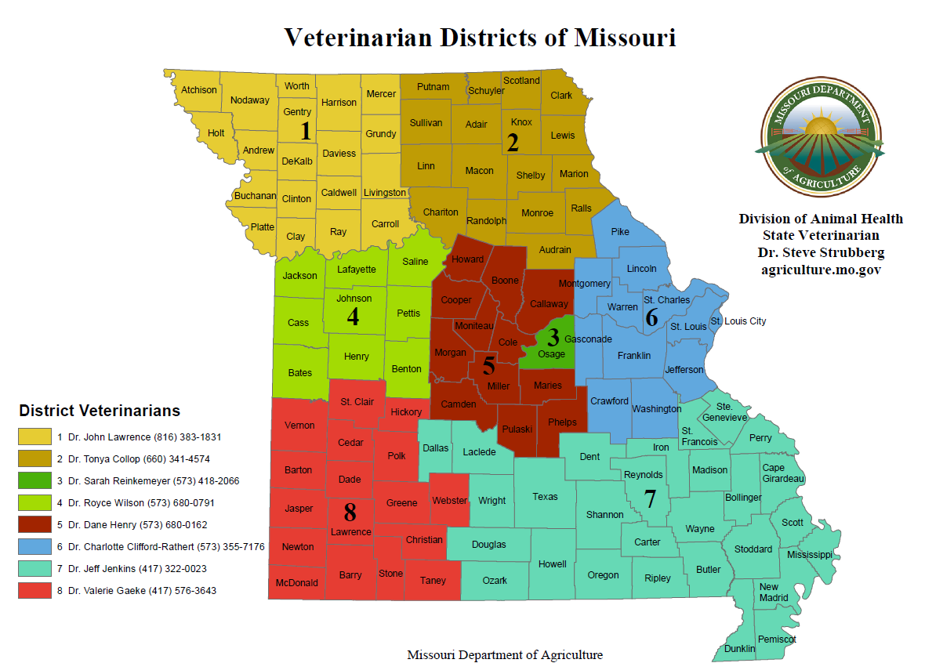

* Missouri Department of Agriculture:

P.O. Box 630

1616 Missouri Blvd.

Jefferson City, MO 65102

(573) 522-1533 (Office of Director)

(573) 751-3377 (Animal Health Office)

(573) 690-9401 (State Veterinarian)

(573) 644-4732 (Emergency Manager)

* United States Department of Agriculture (USDA) Animal Plant Health Inspection Service (APHIS) Veterinary Services (VS):

1715 Southridge Drive  
 Jefferson City, MO 65109

(573) 658-9850 (Main Office)  
(573) 636-3116 (AVIC)

(573) 415-7897 (USDA VS Emergency Coordinator)

LOCAL VETERINARIANS

STATE EMERGENCY MANAGEMENT AGENCY

KANSAS CITY FBI OFFICE

MIDWEST RESPONSE, PO BOX 860534, SHAWNEE, KS - - 916-403-3090

LIVESTOCK MARKETS

LOCAL PRODUCERS/LARGE SCALE FACILITIES

HUMANE SOCIETY

MSHP

COUNTY SHERRIF

AREA HAZMAT TEAM

COUNTY PUBLIC HEALTH

ANIMAL CONTROL

MISSOURI DEPARTMENT OF HEALTH AND SENIOR SERVICES

RED CROSS

*ETC. – Depending on Local Jurisdiction assets, resources and facilities.*

**APPENDIX 4**

**QUARANTINE PROTOCOLS**

In the event that quarantine is required to contain the spread of disease and/or mitigate the economic impact of discovery of a FAD, MDA, through SEMA, will establish the quarantine area and protocols to be followed. SEMA will coordinate state agencies supporting the quarantine and manage resources to assist the local jurisdiction. The depiction below is provided only as a generic example of a quarantine site. Zone sizes could be smaller or larger. There may be multiple quarantine sites and control areas depending on the scale of the disease outbreak.

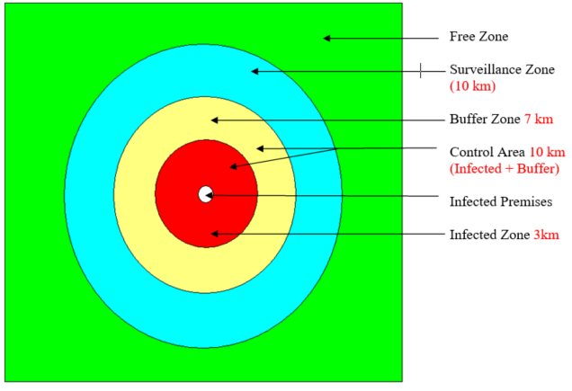

**APPENDIX 5**

**REFERENCES/STATUTORY AUTHORITY**

HOMELAND SECURITY PRESIDENTIAL DIRECTIVE/HSPD – 9

DEFENSE OF UNITED STATES AGRICULTURE AND FOOD, JAN 30, 04

HOMELAND SECURITY PRESIDENTIAL DIRECTIVE/HSPD – 10

BIODEFENSE FOR THE 21st CENTURY

RSMO TITLE XVII, CHAPTER 261

RSMO, TITLE XVII, CHAPTER 267

RSMO, TITLE XVII, CHAPTER 269

RSMO, TITLE V, CHAPTER 44

MISSOURI STATE EMERGENCY OPERATIONS PLAN

CODE OF STATE REGULATIONS, TITLE 11, DIVISION 10, CHAPTER 11

EMERGENCY POULTRY DISEASE (EPD) MANAGEMENT AND INITIAL STATE RESPONSE AND CONTAINMENT PLAN, DECEMBER 2020

**References:**

**RSMO TITLE XVII**

**261.20 -** Gives the Director of AG authority to impose quarantine.

**267.120 -** State Vet may prescribe infected animals and “call for help on the County Commission or legally substituted court … shall order the sheriff or other officer to give assistance necessary to enforce the law”.

**267.179 -** Indemnification for cattle registering positive for tuberculosis.

**267.230 -** Power to enforce fines and class of misdemeanor crime plus says local law enforcement “may” and state law enforcement “shall” assist with enforcement.

**267.240 -** May change existing rules on movement of animals/travel and speaks about the Governor proclaiming a quarantine.

**267.475**

**267.590 & .595 -** Broad authority to the State Veterinarian to quarantine.

**267.611 -** Indemnification – broad authority and can be set by the Director of Agriculture.

**267.645 -** Authority to enter premises and examine livestock.

**267.650**

**Chapter 269 -** Deals with disposal of dead animals and inspections.

**APPENDIX 6**

**RESPONSE EQUIPMENT LIST**

Some counties requested a list of infectious animal disease response equipment and suggestions on where these items could be purchased. This information is included as guidance only and the list is in not all inclusive, these are just suggestions of items that may be useful. This list was included simply for your information.

Boot Brushes

Tyvex Coveralls

Tyvex Booties

Footbath pans

Footbath disinfection chemicals

Local jurisdictions may wish to add other equipment -- A list of the authorized equipment for Ag events in the FY 04 city/county grant instruction might be a good start. In addition, the MDA is acquiring and maintaining a portable response capability that would augment local jurisdiction resources.