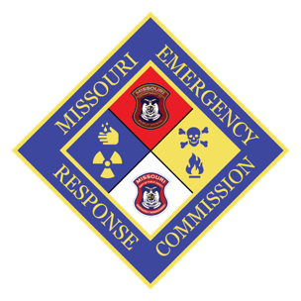
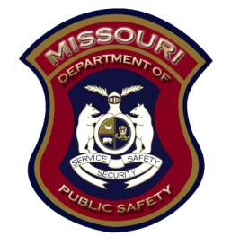
Missouri Emergency Response Commission
2302 Militia Drive PO Box 3133
Jefferson City, Missouri 65102
573-526-9249

Missouri Emergency Response Commission Agenda
Oscar’s Classic Dining

MERC Commissioners

William Brinton, Chairman

Brian Allen, Vice-Chairman

Ronald Walker

Brian Munzlinger

Bill Halmich

Lisa Cardone

Cory Jorgensen

2118 Schotthill Woods Drive
Jefferson City, MO 65109
Conference Call Number: 573-418-9401

10:00 a.m.
October 18, 2019

Welcome/Introductions –
Commission members Present: Bill Brinton, Lisa Cardone, Cory Jorgensen, Bill Kidd, Patrick Seamands, Chris Berndt, Kermit Hargis, Jim Remillard

Staff Present: Paul Kirchhoff, Patti Tye, Lisa Jobe, Karen Eagleson, Steve Shaw

Guests: Brad Harris, Jamie Kidd,

Minutes from previous meeting: A motion was made by Bill K. to accept the minutes as written, seconded by Cory J. and passed unanimously

Reports:
EPA report presented by Dave Hensley
Updated List of List is Now Available
The List of Lists is a consolidated list of chemicals subject to EPCRA, CERCLA, and Section 112(r) of
The Clean Air Act (CAA). It was prepared to help facilities handling chemicals determine, for a specific
chemical, whether they may be subject to certain reporting requirements. For more information visit
www.epa.gov/epcra/consolidated-list-lists-under-epcracerclacaa-ss112r-june-2019-version

Reporting Amendment for Air Emissions from Animal Waste at Forms
On June 4, 2019, EPA Administrator Andrew Wheeler signed a final rule to amend the emergency
release notification regulations under EPCRA. This amendment adds a reporting exemption for air
emissions from animal waste at farms. For more information, visit www.epa.gov/epcra/cercla-andepcra-
reporting-requirements-air-releases-hazardous-substances-animal-waste-farms

Toxic Release Inventory (TRI) Updates
The 2018 TRI preliminary dataset is available and contains data about chemical releases,
waste management and pollution prevention activities that took place during 2018 at more
than 20,000 federal and industrial facilities across the country. For more information see:
www.epa.gov/toxics-release-inventory-tri-program/2018-tri-preliminary-dataset
For TRI related questions contact Sean Bergin at bergin.sean@epa.gov or 913-551-7499.

The EPA new Director is David Cozad

Brad Harris presented DNR report
The Department’s Environmental Emergency Response (EER) staff continues to engage and support local planning efforts through regular attendance at LEPC/LEPD and RHSOC meetings, either as
standing committee members or in an Ex-Officio capacity. The EER staff also represents the Department at EPA Region 7 Regional Response Team (RRT) meetings, associated sub-area committee meetings, and participates in other committees such as EPA Region 7 EPCRA meetings. EER staff attended the EPA Region 7 RRT meeting in Kansas City on September 25-26, 2019 and is registered for the EPA Region 7 EPCRA meeting in Kansas City scheduled for November 13-14, 2019.

Modular Emergency Radiological Response Transportation Training (MERRTT)
The Department, along with partners in the Departments of Public Safety (DPS) and Health and Senior Services (DHSS), are prepared to provide MERRTT to response agencies along Missouri’s radiation transportation corridors. EER staff continue to be engaged with local officials on planning additional classes. In addition, EER staff are working with DHSS, SEMA, and the MERC to schedule refresher classes in Regions H and C. Full classes will be delivered in Regions F and C. These classes are being scheduled for 2020.

Clandestine Drug Lab Collection Station Program
A JAG grant to continue this program has been approved for FY20. The approved grant does not include funding for a 40-hour Clandestine Drug Lab HAZWOPER. Four refresher courses are scheduled to take place in December of 2019. Registration for the recertification courses can be completed online through the Missouri State Highway Patrol. www.mshp.dps.missouri.gov/MSHPWeb/PatrolDivisions/TND/2016Hazmat Recert.html

HAZMAT Resource Typing Project
EER and Division of Fire Safety staff are working on a project to revise federal resource typing of hazmat teams and resources

Chemical Suicide Training
Five EER staff are trained to be able to present this class. Classes are open to local officials and are scheduled through the SEMA training website located at https://www.sematraining.com.

Greg Landwehr presented the Division of Fire Safety report.
The CEPF funding report is, we have obligated approximately $12,000 for upcoming training
and more classes are in the process of being requested and approved for delivery. Changes in the process of how these classes are now requested.

Paul was awarded the Brad Willett award for years of service in the Emergency Management in planning and training in the Hazardous Material Response.

Patti Tye gave the Tier II update.
To date, we have received 8,218 Tier II reports for the 2019-filing year. That is down about 100 from last year. Reports continue to come in on a regular basis.
I have been working on the archive process. This year, I am archiving the 2016 Tier II reports.
I continue to work with our planners to update the hazmat plan database. I have also been working with Homeland Security to assist with information for the National Crosswalk, as well as the 7th CST to provide valuable information to increase their response readiness capabilities.

Karen gave the EPCRA report
Karen Eagleson, EPCRA Specialist report, she followed up on 14 EER incidents. Mailed 5 Payment Letters and has been researching 3632facilities on the gas station list. 792 facilities have been reviewed and has mailed 133 letters.

Karen attended the National Association of SARA Title III Program Officials conference Oct 14-17; she brought a Thumb drive for each commissioner that has information regarding Emergency Planning and Community Right to Know: the Folders are:
Apell - UN Emergency Planning Guide
CAFO,
CAMEO,
EPA 2013 guidance document,
Chemical Emergency Preparedness
Chemical Safety
LEPC update 2013 August
EPCRA Stat & Regulations And Guidance,
EPCRA Statute Title 42 chapter 116
40CFR Part 355 emergency planning
40 CFR Part 370 facility reporting
EPA guidance on 311-312 reporting
Litigation,
NFPA,
NFPA 1600 Emergency Planning guidance
Past Presentations,
PHMSA,
Oil spill Planning
Pipeline Safety
Hazardous trains
Water Utility Emergency Planning
Release of Tier II information from LEPCs to water system facilities that maybe affected in the event of a chemical release to a waterway.
Then the thumb drive included several single documents and fact sheets

The CEPF report.
The MERC continues to receive 2019 CEPF applications.
On the status map, 16 counties are pending documentation on completing their CEPF applications.
I plan to send out the 2020 CEPF applications in December.
Ron Walker, Interim MERC Director, approved 11 CEPF application for 2019 since our last commission meeting.

Lisa Jobe gave the training report that included A List of upcoming trainings were included in commission packets. (list is available upon request.)

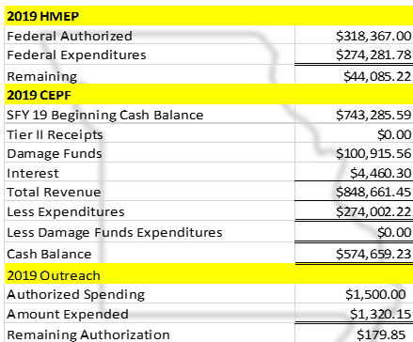

Director’s report was given by Paul K. Paul reported on the monies available through HMEP, and CEPF as shown above.

The MERC presented with the LEPC/D membership lists provided in 2019 CEPF applications
Cory made the motion to accept the LEPC membership listed for Atchison, Callaway, Crawford, Dent, Gasconade, Grundy, Maries, Osage, Phelps, St. Louis City and Washington. Lisa C second the motion and passed

In addition there are 16 LEPC/D CEPF applications pending,

Paul also addressed the commission on excess MERC training equipment.
We currently have two large pieces of training equipment that either are no longer being used (CERT Training Trailer Model #610) or have never been used (MC306 Tank Model). Due to limitations in transportation of the training aids as well as a lack of need for the equipment, we are recommending divesting the MERC of the aids.

CERT Training Trailer – Our trainers would have to have a method to transport the trailer to the desired location. We would also have to revise their contracts to accommodate the added expense. We currently contract this class outside of the MERC Trainers. The trailer must be maintained and licensed.

MC306 Tank Model – This training aid must also have a method to transport the aid to the desired location. Its construction is such that it would have to be loaded on a trailer and moved. It was designed to be in a single location for centralized training. The devise also does not meet the desired needs of the trainers in that it does not tilt of simulate the spill/leak of a product. It has been housed in the warehouse and never used.

Lisa also spoke about the MC306 Prop and the Anhydrous Ammonia Training Trailer Requests. A few counties were interested and after discussion those counties will be invited to attend the next MERC meeting to pitch why they want the prop.

Motion to adjourn made by Bill K. Second by Paul K. Motion carried

.
Meeting adjourned.

Respectfully Submitted,
Lana Nelson

